Supporting: MSFKB3005 Fabricate cabinets for the built-in environment

Section 2 Assignment: Cutting and edging
Name |  | Date

Question 1
Name the parts labelled on the saw diagram below, and provide a brief explanation of their purpose.
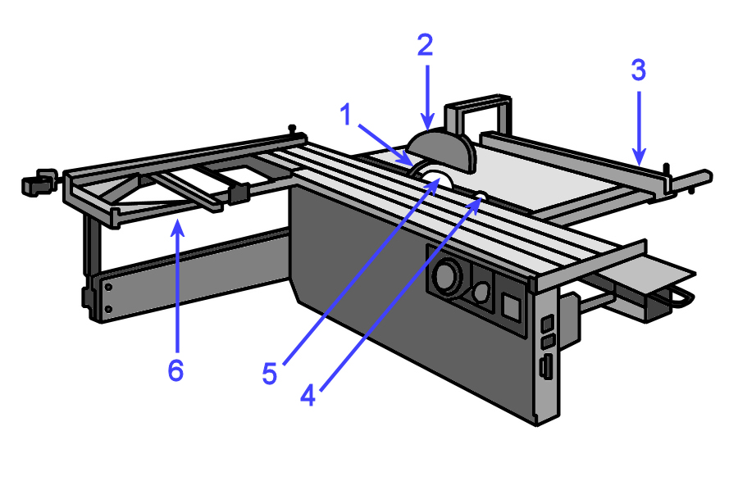

No | Part name | Purpose
1
2
3
4
5
6

Question 2
You need to cut the components shown below from a single sheet of 2400 x 1200 x 16 MDF. Once the components are cut to size they will be sprayed with a high gloss polyurethane lacquer.
Item | Quantity | Height | Width | Material
Doors | 6 | 745 | 450 | 16 mm MDF
Drawer fronts | 6 | 160 | 450 | 16 mm MDF

- Draw up a cutting pattern to show how you will recover these components from the sheet plan shown below.

1200

2400

- If the surface finish had been a sliced-cut timber veneer (instead of polyurethane) would you have been able to use the same cutting pattern? Why or why not?

Question 3
Describe one potential quality problem that you should look out for at each of the following stages of the production process. For each problem, describe the most likely cause (or causes), and provide a possible solution.
- When the board is picked up off a stack held in storage
Problem:
Cause:
Solution:
- When the board is cut to size on a panel saw
Problem:
Cause:
Solution:
- When the board is edged on an edge bander
Problem:
Cause:
Solution:

