Supporting: MSFKB3002 Determine requirements for installation of cabinets

Section 2 Assignment: Construction features
Name |  | Date

The drawing below shows a section through a building.
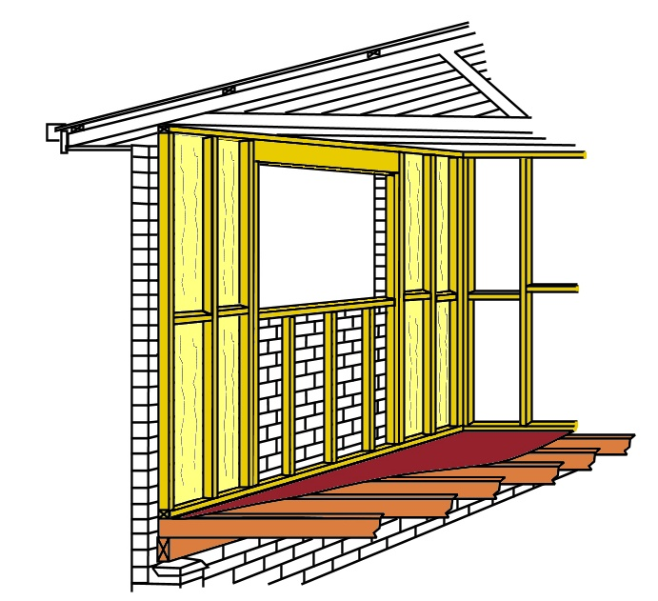

1
2
3
4
5
6
7

- Name each of the parts that are numbered

2. What type of wall structure does this drawing represent?

