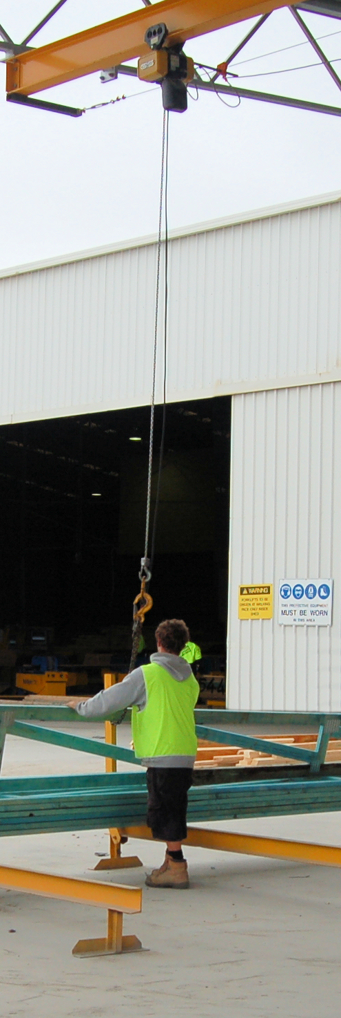
Working safely
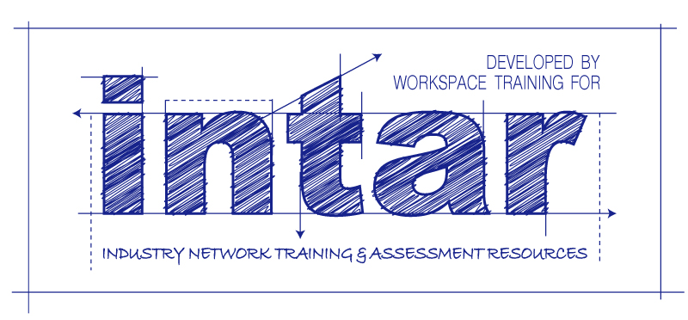
Supporting:
MSAPMOHS200A: Work safely

INTAR K&B Project 2015
Learner guide

Working safely
Learner guide

This Learner guide is part of a suite of resources developed for learners undertaking the MSF31113 Certificate III in Cabinet Making (Kitchens and Bathrooms). Its purpose is to help apprentices and other workers to acquire the background knowledge needed to satisfy the theoretical components of the competencies covered. It is not designed to replace the practical training necessary to develop the hands-on skills required.

E-learning version
All of the content material contained in this Learner guide is also available in an e-learning format, which has additional photos, interactive exercises and a voice-over narration of the text. The e-learning version can be viewed on the web at: www.intar.com.au

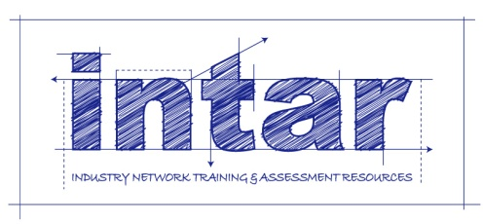

ISBN: 978-1-925087-33-8

Copyright
Parts of this resource are based on material developed by Workspace Training for the original Flooring Technology Project, produced in 2011-2014 for the Workplace English Language and Literacy (WELL) Program.
The original WELL project was funded by the Commonwealth Government, which owns the copyright to that material under a Creative Commons Attribution-Noncommercial-Share Alike 3.0 Australia Licence. This original resource is freely accessible to all web users, and can be viewed on-line on the Industry Network Training and Assessment Resources (INTAR) website at: www.intar.com.au.
Copyright in all new text, photographs and graphics is owned by McElvenny Ware Pty Ltd, trading as Workspace Training. This work was funded by INTAR. All enquiries should be addressed to:
David McElvenny
Workspace Training
PO Box 1954 Strawberry Hills, NSW, 2012
Email: david@workspacetraining.com.au

Disclaimer
The content of this resource is provided for educational purposes only. No claim is made as to its accuracy or authenticity. The authors, copyright owners and INTAR do not give any warranty nor accept any liability in relation to the information presented in this work.
In all cases, users should consult the original source documents before relying on any information presented in the resource. These source documents include manufacturers’ installation guides, Australian Standards, codes of practice and other materials produced by specialist industry bodies and government agencies.

About INTAR
Industry Network Training and Assessment Resources (INTAR) is a partnership owned by Workspace Training and Vaughan Consulting Software Solutions – the development team that produced the original Flooring Technology project for the Commonwealth Government WELL Program.
INTAR was formed to enable the development work to continue, following the abolition of the WELL Program in 2014. All new materials are now paid for by subscribers and members who contribute to the INTAR funding pool. Access to the subscription site is via a password protected area.
Members of INTAR include TAFE teachers, RTO trainers, manufacturers and other suppliers of industry products and services.
In addition to learner guides, workbooks and on-line materials, INTAR also provides members with the following resources and services:
- nationally validated assessment tools for all competencies covered in the learning materials
- participation in the validation groups that meet to validate assessment tools and strategies
- forums for direct consultation with manufacturers, employers and other industry personnel
- evidence of the continuous improvement, validation and consultation processes, suitable for use in demonstrating compliance with the Standards for RTOs 2015.

Acknowledgements
The INTAR project team comprises the following people:
David McElvenny (Workspace Training) – lead writer and project manager
Kath Ware (Workspace Training) – instructional designer and graphic artist
Jim Vaughan (VCSS) – technical developer and programmer
Alex Vaughan (VCSS) – assistant programmer and voice-over narrator
Giselle Mawer (Giselle Mawer and Associates) – quality assurance consultant and auditor.
To see the full list of people involved in the Technical Advisory Group for the original WELL Program Kitchen and Bathroom Cabinetmaking project, please go to the INTAR website and follow the links.

Photos and graphics
Most graphics were drawn by Kath Ware. Many of these are based on line drawings or photographs provided by manufacturers.
Site plans and other CAD drawings were provided by manufacturers.
Photos were taken by David McElvenny

Table of contents_Toc408562186
Introduction 1
Section 1 Safety policies and procedures 3
Overview 5
Rights and responsibilities 7
Workplace procedures 10
Consulting with employees 15
WHS management systems 17
Assignment 1 21
Section 2 Managing risks 23
Overview 25
Identifying hazards 26
Assessing risks 28
Controlling risks 30
Wearing PPE 33
Manual handling 36
Assignment 2 38
Section 3 Dealing with emergencies 39
Overview 41
Emergency evacuations 42
On-site fires 45
Hazardous spills 50
Assignment 3 54
Practical demonstration 55

Introduction
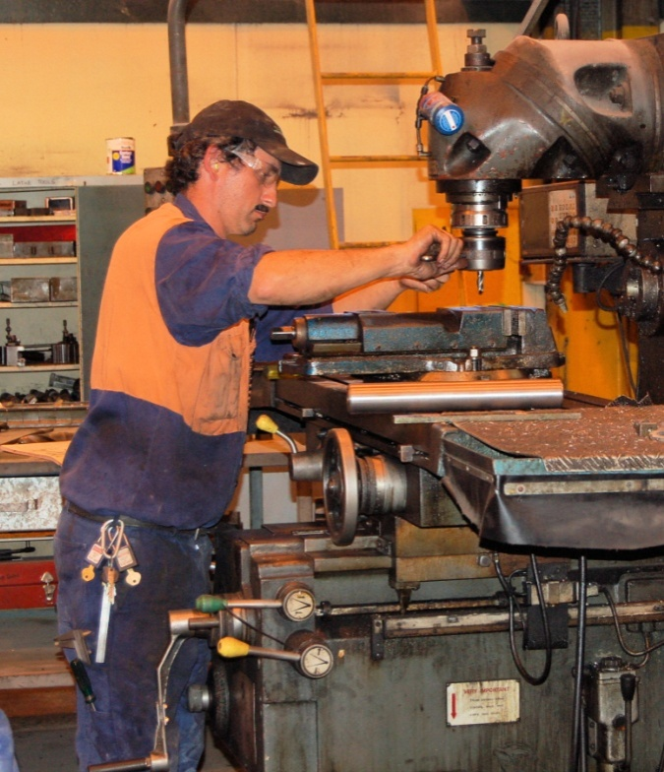
Safety is a big issue in the manufacturing industry. It’s not hard to see why. The industry is full of jobs that require people to work with machines and chemicals, and carry out tasks that could be very hazardous if they weren’t done with a lot of care.
The Australian Bureau of Statistics has said that on average, 60 workers are injured every day in manufacturing incidents that result in them taking one or more weeks off work (Manufacturing fact sheet 2011-12 on the Commonwealth Government website: Safe Work Australia).
The good news, though, is that workers’ compensation claims for serious injuries and illnesses are on the decrease. Over the last 10 years there has been a reduction of 27% in serious claims. This is due to several reasons, including stronger laws and regulations, better equipment, safer work practices, and a greater awareness among workers of risks and how to deal with them. It just shows that when everyone plays their part in making the workplace safer, people are less likely to get hurt.
This learner guide will look at the main laws and regulations that govern safety in the manufacturing industries, and how this affects the way you need to carry out your work. In particular it will cover some of the procedures used by manufacturing workers to ensure that they maintain a safe workplace in their day-to-day operations.

Working through the unit
There are three sections in this unit:
- Safety policies and procedures
- Managing risks
- Dealing with emergencies.
Each section contains an Overview, an Assignment, and several Lessons which cover the content material.

Assignments
Your trainer may ask you to submit the assignments as part of your assessment evidence for the unit. You will find hard-copy templates for these assignments in the separate workbook.
Electronic ‘Word’ templates of the assignments are available on the website for this resource, at: www.intar.com.au

Learning activities
Each of the lessons has a learning activity at the end. The Workbook for this unit contains all of the learning activities together with spaces for written answers.
Again, you will find the learning activities on the website version, together with some interactive ‘Just for fun’ exercises.

Practical demonstrations
Your final assessment of competency in this unit will include various practical demonstrations. To help you get ready for these hands-on assessment activities, see the sample checklist shown in the Practical demonstrations section at the back of this Learner guide.

Section 1

Safety
policies and
procedures

Overview
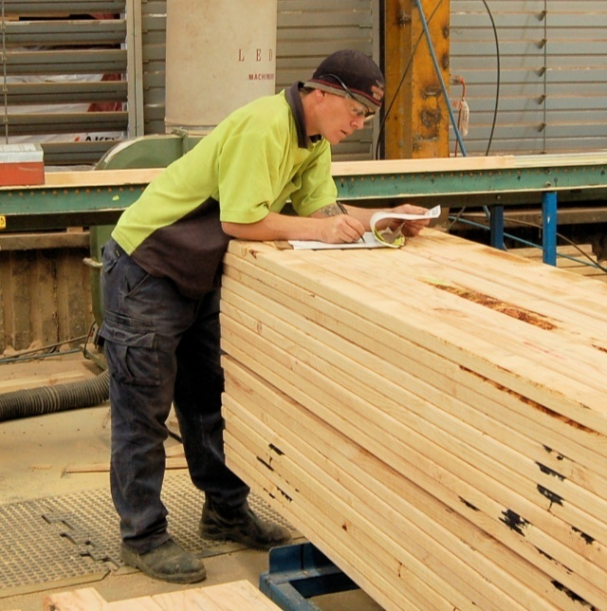
Companies spend thousands of dollars keeping their Work Health and Safety (WHS) system up-to-date, so that it stays compliant with changing legislations, codes of practice and insurance company requirements.
But the bottom line can always be summed up in the basic question:
Is the system making the workplace safer?
... Yes
If the answer is ‘Yes’, then your safety system is working. Not that this means you can be complacent, and start to take it for granted. An effective system is only effective while people continue to follow its procedures and policies in their daily activities.
... No
If the answer is ‘No’, then you’ve got a serious problem on your hands. No-one likes filling out forms if they think it’s pointless. And people soon lose the motivation to follow strict work procedures if they don’t see any benefit in it.
Once employees start to feel that the company’s safety policies and procedures are more trouble than they are worth, they’re much more likely to take shortcuts, or think that the procedures don’t apply to them. And this is when the chance of an accident happening becomes an odds-on bet.
In this section, we’ll look at the legislation that underlies safety in the workplace, and the administrative system that turns these laws into practical activities that can be applied on the job.

Working through this section
The assignment for this section asks you to review the role you play in the company's WHS system. Have a look at Assignment 1 on page 21 to see what you’ll need to do to complete it.
There are also four lessons for this section:
- Rights and responsibilities
- Workplace procedures
- Consulting with employees
- WHS management systems.
These lessons will provide you with background information relevant to the unit of competency.

Rights and responsibilities
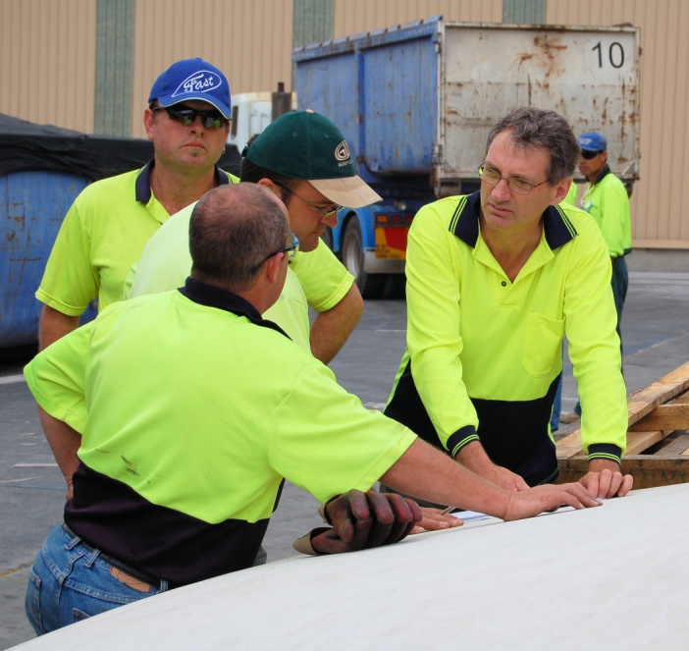
In general, the rights and responsibilities of all people in the workplace are defined in the Work Health and Safety (WHS) Act that applies to your state or territory. There are also Regulations that expand on particular aspects of the Act and provide details on how it should be implemented.
The various state and territory governments have been working towards aligning their Acts and Regulations with ‘model’ laws developed by the federal government body called Safe Work Australia.
It was hoped that this harmonization process would be completed by January 2012. However, some states are still operating under their old laws while they work through the changes needed to comply with the new national model.
All state and territory Acts say that everyone has a duty of care to ensure that their actions don’t jeopardise the safety or welfare of others. Everyone in the workplace is also required to report any hazards that they notice, so that steps can be taken to minimise the risk of the hazard causing an injury or illness.
In addition to this shared responsibility for safety, there are specific responsibilities relating to each level of employment.

Responsibilities
On the following page is a summary of the main responsibilities for each level of authority in an organisation. Note that different companies will have their own sets of job descriptions, and particular duties may vary between positions, depending on the way the company has decided to share out the tasks. But in the end, each of the responsibilities needs to be designated to an appropriate person.

Directors are responsible for:
- ensuring that the company’s WHS policies are effective in keeping the workplace safe
- ensuring that the company’s activities comply with all WHS legislation.

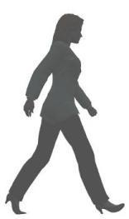 | Managers are responsible for:  - developing and implementing safe work policies and procedures  - consulting with the workforce on WHS issues  - distributing all relevant information to employees.
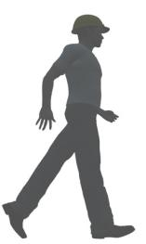 | Supervisors are responsible for:  - supervising employees’ work performance  - ensuring that appropriate training is given to employees  - carrying out regular safety inspections  - correcting unsafe work practices and disciplining employees who disregard WHS policies.
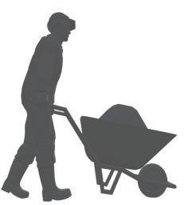 | Workers are responsible for:  - taking care of the health and safety of themselves and others who may be affected by their actions  - working in accordance with safe operating procedures and other safety directions from management  - reporting hazards or unsafe work practices to their supervisor  - reporting any injuries to their supervisor  - cooperating in health and safety programs.

Rights
The WHS Acts also give workers certain rights. For example, workers have the right to raise genuine safety issues with their supervisor or manager, and have their concerns taken seriously. They are also protected from discrimination if they report a hazard or unsafe work practice.
Safety officers and WHS committee members are also protected under the Act from discrimination as they carry out the duties relating to that position, such as undertaking site inspections or investigating the causes of accidents.

Learning activity
What are your responsibilities for safety in your own workplace? Use the checklists above as a guide, and include any extra responsibilities that apply to your particular job role.
Write down the main points and share them with your trainer and other learners in your group.

Workplace procedures
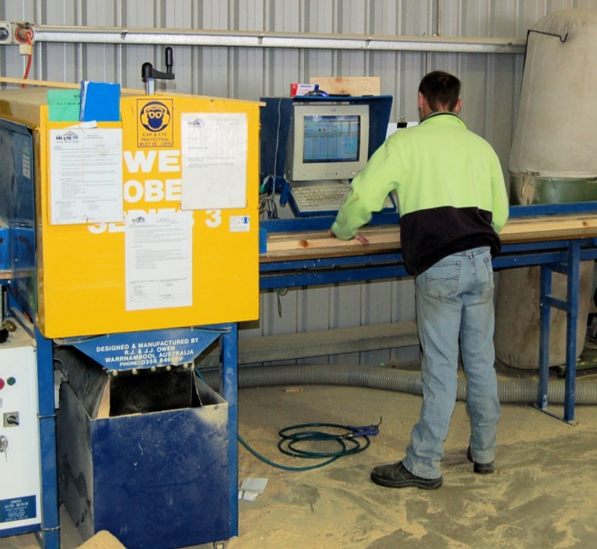
Workplace procedures are used to provide employees with approved methods of carrying out particular tasks.
One way of writing up a workplace procedure is to use the format of a Safe Operating Procedure, or SOP. This can be posted up on a laminated page near the machine. Some companies also use SOPs to verify that the operator has been trained in that procedure by asking them to sign a copy, which is then kept in their personnel file.
More complex safety procedures can be documented in the form of a Job Safety Analysis (JSA), also known as a Safe Work Method Statement (SWMS). The layout of these documents makes it easier to show multiple tasks and include the responsibilities of different personnel.
Particular types of procedures are included in the company’s Policies and Procedures Manual. These include tasks such as housekeeping, machine isolation and reporting faults. Some of these are also reproduced in the Employee Induction Manual, so that new employees can be made aware of them before they start work.
On the following pages are three different examples of the way workplace procedures can be written up. These examples are:
Isolation procedure (from a Policies and Procedures Manual)
Safe Operating Procedure (posted up beside a machine in the workplace)
Job safety analysis (used by workers on-site)

Isolation procedure (from a Policies and Procedures Manual)

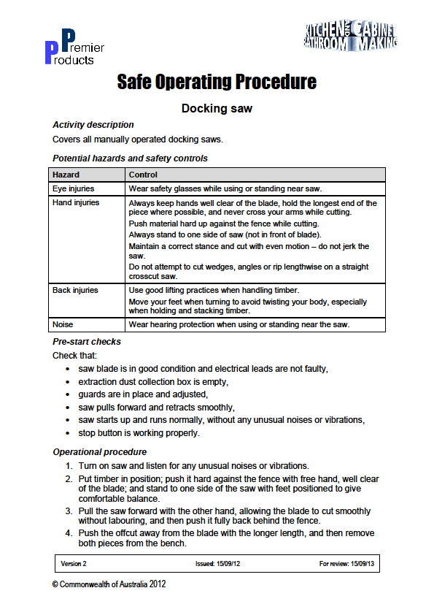Safe Operating Procedure (posted up beside the docking saw in the workplace)
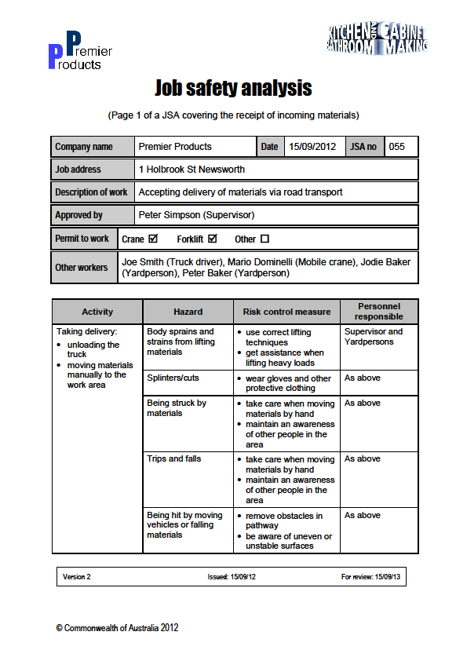Job safety analysis (used by workers on-site)

Learning activity
Whether you work in a factory, office, workshop or out on-site, there will be a range of company procedures that you are required to follow as you go about your job. The three examples we’ve looked at in this lesson use formats that are common in the manufacturing industries. But there are other ways of writing up procedures so that employees know what the approved methods are for doing particular tasks.
What types of procedures do you need to follow in your day-to-day work? Make a list of the names of the main procedures you use and describe the format they are presented in.
Share your answers with your trainer and other learners in your group.

Consulting with employees
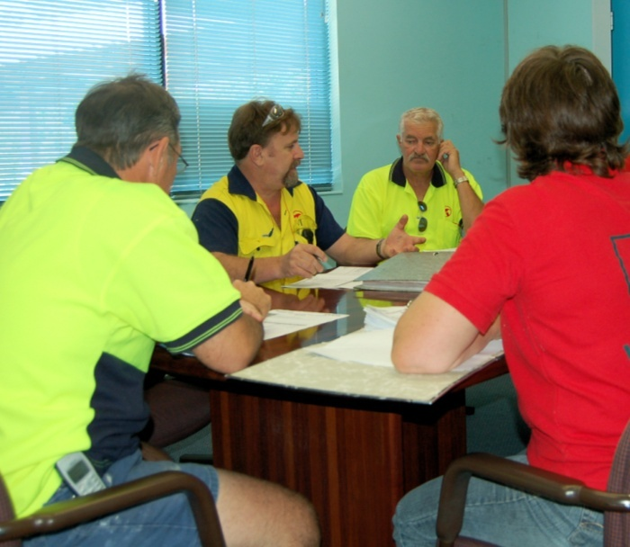
Experienced machinery operators and production workers generally have a very good idea of where the hazards are in their own work area. They’re also likely to feel a lot more inclined to put new work methods into practice if they’ve had a hand in developing them.
This is why consultation between management and the employees is essential for any WHS system to work properly. It’s also a requirement under the law.
Employers are required to consult with their employees whenever:
- issues arise that have WHS implications for employees
- risk assessments are undertaken
- new measures are put in place to control risks
- new work or safety procedures are introduced
- decisions are made about the facilities provided for the welfare of employees
- changes to the workplace, plant or systems of work occur which may affect safety and welfare.

Methods for consulting with employees
Depending on the size of the workplace, there are various ways a company can consult with its workers and meet the requirements of the legislation.
Larger organisations generally have a safety committee that meets regularly and has members representing the employer and employees. The purpose of the meetings is to discuss safety issues and review safety systems. Formal minutes are taken at each meeting, and particular members are given duties to carry out in the workplace, which need to be reported back to the committee when completed.
Companies with large groups of employees also conduct regular toolbox meetings with the workers. These are generally organised by the supervisor in each section of the workplace, and formal minutes are taken of the issues discussed and the decisions made. A toolbox meeting allows employees to raise safety concerns or report hazards. It also lets the supervisor pass on WHS information, or discuss new work practices or procedures that are being introduced.
Regardless of the size of the workforce, all businesses are required to have arrangements in place that allow the free flow of information between the employer and employees. In the case of a small business, this may simply involve workers speaking directly to their boss.
But whatever the arrangements are, documentary records must be kept to show that consultation is occurring properly, and that employees’ views are being considered when management makes decisions about workplace health and safety.

Learning activity
What are the consultation arrangements in your organisation? For example, do you have regular toolbox meetings? Do you have a safety committee or safety representative?
How is employees’ feedback on WHS issues recorded and passed on to management? Are minutes taken at toolbox meetings? Is there a log book where employees can report hazards?
Write down your answers and share them with your trainer and other learners in your group.

WHS management systems
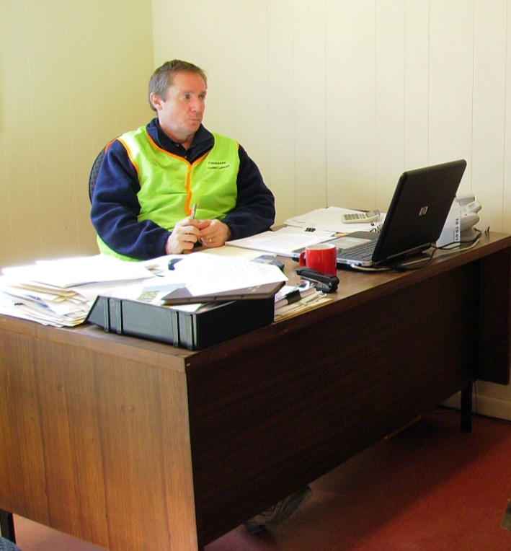
If your WHS system has turned into a big paper shuffling exercise, then it’s not doing the job it’s supposed to. A good system doesn’t need a lot of fancy documents, but it does need a user-friendly set of policies, procedures, forms and checklists – to help encourage everyone to keep it up-to-date, and most importantly, put it into practice while they’re working.
For the system to be truly efficient and fully compliant with legislation, it also needs to be integrated into all of the company’s activities, and managed in a systematic way.
This is where a WHS management system comes into play. It is the overarching system that coordinates all of the safety policies and procedures in the company, and allows management to monitor the performance of the different elements.
It also provides the company with a means for recording its efforts in dealing with safety issues. This not only provides evidence that the company is complying with WorkCover requirements, it also gives the directors a sound picture of how well everything is working.
Set out below are the names and descriptions of typical documents that a company might keep in its WHS management system.

Registers and log books
- Injuries Register: recording all workplace injuries sustained by employees.
- Lifting Gear Register: listing all slings, chains and other lifting gear used on site.
- Hazardous Substances Register: listing all hazardous substances kept on site.
- Plant and Equipment Register: showing the servicing and maintenance schedule for all machines.
- Safety Hazard Log: used by employees to record potential safety hazards.

Workplace safety inspections
- Site Inspection Checklist: used at regular intervals to identify hazards around the site.
- Forklift Pre-start Inspection Checklist: completed by the forklift driver each day.
- Delivery Truck Pre-start Inspection Checklist: completed by the truck driver each day.

Minutes of meetings
- Toolbox Minutes: recorded by the supervisor at the regular Toolbox meetings.
- Safety Committee Minutes: recorded by the secretary at the regular safety committee meetings.

Training documents
- Training Needs Analysis: showing the areas where training is needed.
- Training Skills Matrix: showing the current skills and proposed training for each employee.
- Assessment Instruments: completed by a workplace assessor to verify the competency of employees.

SOPs and MSDSs
- Safe Operating Procedures: showing the safe operating procedures for workplace machines and processes.
- Materials Safety Data Sheets: showing the properties and correct handling procedures for all hazardous substances kept on site.

Risk assessments and reports
- Incident Report: completed after an incident involving property damage or injury.
- Risk Management Assessment: completed by the Safety Committee.
- New Equipment Risk Assessment: completed prior to commissioning a new machine.
- Safe Work Method Statements: completed by subcontractors or other staff involved in installations or other forms of new work.

Return to Work documents
- Return to Work Plan: for injured workers returning to work on ‘suitable duties’.

Forms
- Contractor Insurance Form: completed by contractors prior to carrying out work.
- Hot Work Permit: completed by tradespersons before undertaking hot works, such as welding.
- Workers Compensation Claim Form: completed by injured workers when lodging workers compensation claims.
- WorkCover Accident Report Form: for reporting serious accidents or incidents to WorkCover.

Safety Induction manuals
- Induction Manual for Employees: issued to new employees at the commencement of their employment.
- Induction Manual for subcontractors: issued to contract tradespersons who come on-site.

Policies and procedures manuals
- WHS Policies and Procedures Manual: setting out the company’s Occupational Health and Safety Management System Policies and Procedures.
- Emergency Procedures Manual: setting out the procedures for dealing with emergencies.

Learning activity
In the Workplace procedures Learning activity (page 13) you listed the different types of procedures you use at work. But as you can see, there are many other types of documents included in a company’s WHS system.

- What other documents are you involved with from your company’s WHS system in the course of your normal work
duties?
- Do you use any WHS-related forms or documents that are not described above? If so, what are they, and what category would they come under?
Write down your answers and share them with your trainer and other learners in your group.

Assignment 1
Depending on your level of authority in the organisation, your responsibilities for following or implementing safety policies and procedures will vary. This assignment is designed to be a review of the role you play in the company's WHS system.
To help you answer the questions, you may wish to refer to your Job Description or the company's WHS Policies and Procedures Manual. You may also find it useful to look up the WorkCover website in your state or territory for more information on particular topics, such as the Codes of Practice that relate to your work.
Provide short answers to the following questions:
- What is your job title?
- What are your 'duty of care' obligations under the WHS Act?
- Are there any codes of practice that apply to your work? If so, what are they?
- Describe your input into 'workplace consultation'. For example, are you a member of the safety committee; do you lead or participate in toolbox meetings; do you undertake safety inspections or risk assessments?
- a) List the safe operating procedures (SOPs) or safe work method statements that are most relevant to your day-to-day work. If you use many SOPs, list the three most important ones.
b) Where are these documents kept?
c) How are these procedures made known to employees? For example, do workers sign off against each SOP they are required to follow; are they assessed against it before they are allowed to work unsupervised?

Section 2

Managing
risks

Overview
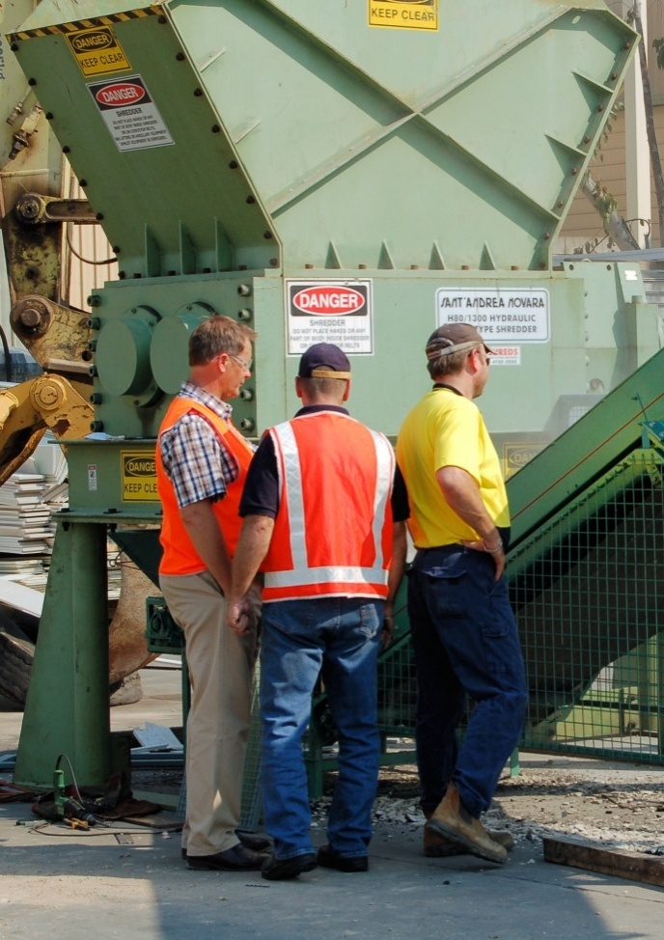
Risk management is all about identifying hazards and minimising – or ‘controlling’ – the risk of them causing an illness or injury.
The most effective way to identify risks and decide on what action that should be taken is to carry out a risk assessment, using the following three steps:
- identify the hazards
- assess the risks
- control the risks.
Employers have a legal responsibility to identify, assess and control risks whenever they install new equipment, or change the way things are done, or find that new information has become available on the materials or processes they use.
In this section, we’ll look in detail at the three-step process of carrying out a risk assessment.

Working through this section
The assignment for this section will introduce you to the process of carrying out a risk assessment. Have a look at Assignment 2 on page 38 to see what you’ll need to do to complete it.
There are four lessons for this section:
- Identifying hazards
- Assessing risks
- Controlling risks
- Wearing PPE.
These lessons will provide you with background information relevant to the unit of competency.

Identifying hazards
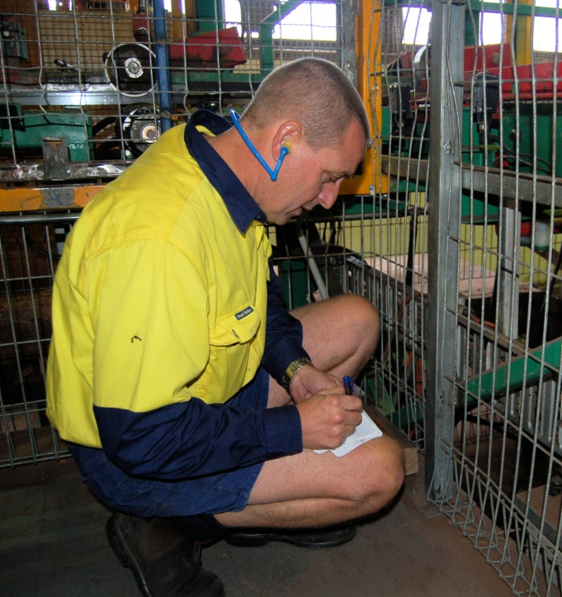
A hazard is anything that might harm the health or safety of someone. Depending on the workplace, it could include airborne dust, sharp objects, obstacles, electrical currents, vehicles, noise, or anything else that might cause an injury or illness.
The most obvious way to identify hazards is to go out into the workplace and look for them. But there are other methods of finding potential hazards.
Here are the most common methods used to identify hazards:
- carry out a workplace inspection
- talk to employees and safety representatives
- check injury records
- check the ‘safety hazard log book’
- get expert advice from an industry consultant
- review the codes of practice and other advisory documents.

Learning activity
To be effective at identifying hazards, you need to know what sorts of injuries tend to be associated with particular work conditions, or types of machines, or certain sorts of tasks.
Have a look at the statistics table on the following page to see what the most common injuries are in the manufacturing industry, and the main causes of those injuries.
Have you or your work mates ever suffered from any of these injuries? Think about the causes and any changes you made afterwards to the way you did your job. Did these changes reduce the chance of the injury happening again?
Share your answers with your trainer and other learners in your group.

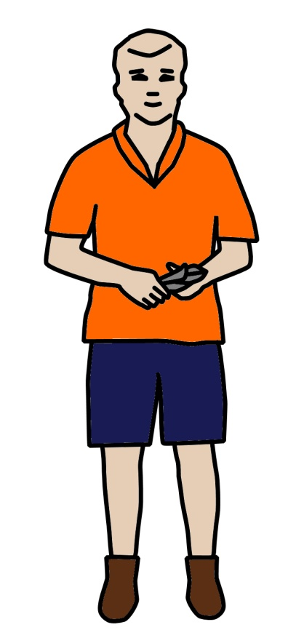
1
2
3
4
5
6
7
8
9
10

Table of injury statistics
No. | % total injuries | Body part | Injuries
1 | 24% | Hand and fingers | Lacerations and open wounds
2 | 16% | Back | Sprains and strains from bending, lifting or carrying
3 | 11% | Eye | Fragments in eyes from grinding or welding
4 | 7% | Shoulder | Sprains and strains from repeatedly lifting or moving things
5 | 5% | Knee | Sprains and strains from kneeling, crouching or twisting
6 | 5% | Wrist | Sprains and strains from repeatedly lifting or moving things
7 | 3% | Ankle | Sprains and strains from tripping or falling over
8 | 3% | Foot and toes | Bruising and crushing from falling or dropping objects
9 | 3% | Elbow | Sprains and strains from repeatedly doing the same thing
10 | 3% | Forearm | Wounds from using knives
Adapted from Injury statistics for manufacturing, from Queensland Worksafe: www.worksafe.qld.gov.au

Assessing risks
Once the hazards have been identified, they can be given a risk rating, depending on how urgently they need to be addressed.
Below is a typical risk assessment table used to rate the likelihood of an accident occurring and the severity of the injury that might result. This allows a priority rating to be put against each of the hazards identified, so that the most serious ones can be dealt with first.

Risk Assessment Table | Very likely  Could happen any time | Likely  Could happen sometime | Unlikely  Could happen but rarely | Very unlikely  Could happen but probably never will
Kill or cause permanent disability or ill health | 1 | 1 | 2 | 3
Long term illness or serious injury | 1 | 2 | 3 | 4
Medical attention and several days off work | 2 | 3 | 4 | 5
First aid needed | 3 | 4 | 5 | 6

Adapted from the NSW WorkCover publication: Hazpak – Making your workplace safer.

Learning activity
Joe is the Safety officer in a small manufacturing workplace. He has just completed a site inspection and has identified four hazards. The hazards are described below along with the likelihood and the severity of the injuries that may result. Joe has asked you to give each of these hazards a risk rating.
Refer to the table on the previous page which ranks risks from 1 to 6. You may do this exercise with a partner if you wish, so that you can discuss the issues before you decide on an answer.
Write down your answers and share them with other learners in your group and your trainer.
Hazard
There is a shallow pothole near the entranceway to the storage shed. Forklifts could tilt to one side if a tyre went into the hole, which might de-stabilise the load they were carrying.
It is likely that this could happen sometime, and if it did, it might result in someone being injured, possibly seriously if they were standing nearby.
A manually-operated radial arm saw has a steel plate mounted to the guard to provide extra protection to the operator’s hands. However, the plate makes it difficult to see the blade properly, and the operator sometimes has to look in under the guard while they’re cutting.
Although they wear safety glasses, it is very likely that small particles could fly out and hit them in the face, which may require first aid.
The new overhead gantry crane will be fully installed and operational in two more weeks, but no-one on-site knows how to use it yet.
Unless it is used properly and in accordance with strict safety procedures, it could cause potentially fatal accidents which may happen at any time.
The storeperson sometimes uses an electric chainsaw to cut timber bearers and packing case materials into shorter lengths. However, there are times when he has to run an extension lead across the pedestrian walkway to get to the timber.
Although it’s unlikely, there is the chance that someone may trip over the lead, which could result in a sprained ankle and several days off work.

Controlling risks
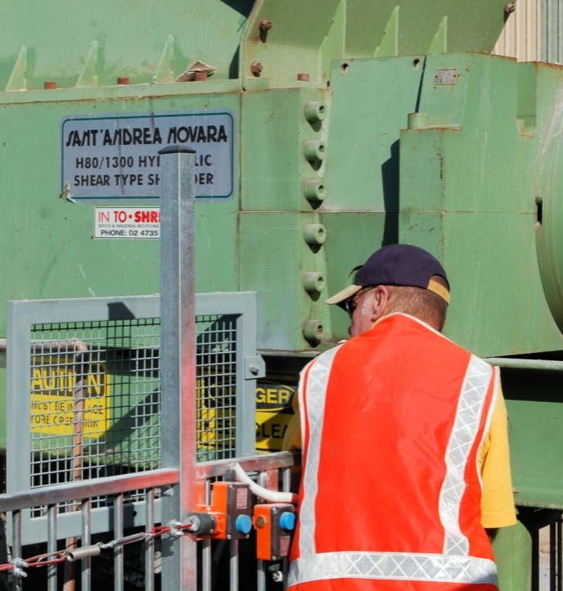
Most hazards can be controlled in a variety of ways. Obviously, the best control would be to eliminate it completely. But that isn’t always possible.
So the most practical process for deciding on how to address a hazard is to find these best control measure from the ‘hierarchy of controls’. It's called a hierarchy because you start at the top of the list – removing the hazard from the workplace – and work progressively down to the bottom – accepting that the hazard must remain and providing personal protective equipment.

Hierarchy of controls
Below is the order you should work through to find the control that is most appropriate. In many cases, you may find that more than one control is necessary. For example, training might be used as one of the controls with most hazards.
- Eliminate the risk, such as through removing the dangerous machine or situation, or changing the way the job is done
- Substitute the hazardous machine or process with a safer one
- Engineer a solution to control the risk, such as with guards, dust extraction systems or other mechanical aid
- Isolate the machine, process or area to keep employees clear of the hazard
- Train employees to avoid the risk, such as through the use of Safe Operating Procedures
- Issue personal protective equipment to employees, such as hearing protection, eye protection or safety boots.

Learning activity
Joe has looked at your risk ratings from the previous Learning activity and has now given each hazard a formal risk rating of his own. He has also decided on one or more control measures. These are shown in the table below.
See if you can identify which category each of the control measures falls into from the Hierarchy of controls.
Write down your answers and share them with other learners in your group and your trainer.
Here are your choices:
Eliminate Substitute Engineer Isolate Train PPE

Hazard | Risk rating | Control measure
- There is a shallow pothole near the entranceway to the storage shed. Forklifts could tilt to one side if a tyre went into the hole, which might de-stabilise the load they were carrying.  It is likely that this could happen sometime, and if it did, it might result in someone being injured, possibly seriously if they were standing nearby. | 2 | - Tape off the area so that forklifts can’t drive over the pothole.
 |  | - Make arrangements for the bitumen to be resurfaced around the storage shed.
2. A manually-operated radial arm saw has a steel plate mounted to the guard to provide extra protection to the operator’s hands. However, the plate makes it difficult to see the blade properly, and the operator sometimes has to look in under the guard while they’re cutting.  Although they wear safety glasses, it is very likely that small particles could fly out and hit them in the face, which may require first aid. | 3 | 1. Ask the maintenance staff to replace the steel plate with a Perspex plate, so that the operator can look through it to see the blade.
- The new overhead gantry crane will be fully installed and operational in two more weeks, but no-one on-site knows how to use it yet.  Unless it is used properly and in accordance with strict safety procedures, it could cause potentially fatal accidents which may happen at any time. | 1 | 1. Enrol designated workers in a ‘dogging’ course, and make sure they are accredited with a WorkCover licence before being allowed to use the crane.
 |  | 2. Require all people working in the vicinity of the crane to wear hard hats when it is being used.
- The storeperson sometimes uses an electric chainsaw to cut timber bearers and packing case materials into shorter lengths. However, there are times when he has to run an extension lead across the pedestrian walkway to get to the timber.  Although it’s unlikely, there is the chance that someone may trip over the lead, which could result in a sprained ankle and several days off work. | 4 | 1. Buy a small petrol chainsaw and use it instead of the electric one.

Wearing PPE
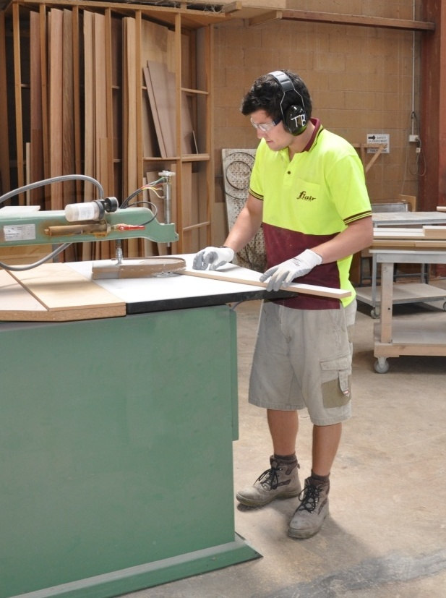
In the last lesson, we talked about the use of personal protective equipment (PPE) as the last line of defence to control hazards that might cause an injury or illness. There are many jobs that require people to wear PPE.
Some items, such as safety boots, are often compulsory for all people on-site. Other items are generally specified for particular jobs, such as safety glasses when using certain machinery or ear muffs when in a noisy area.
Your company will have set procedures for the different items of PPE that you are required to wear. There might also be signs up on the wall or over entranceways to alert people to the PPE items required in particular work areas.
It's important to remember that if your company has made it a requirement to wear PPE, you have a legal obligation under the WHS Act to do so. So if you get hurt and you're not wearing the necessary safety gear, you might end up being in trouble with the law, quite apart from any injuries you suffer.
Below are the main items of PPE and their corresponding safety signs.
Safety sign | Description

Safety helmet, or hard hat
Workers are normally required to wear a hard hat in any area where there is a danger of falling objects, or where equipment is being operated overhead.

High visibility vest
Anyone who works near trucks, forklifts or other vehicles or machinery should wear a high visibility vest to make them as visible as possible to nearby operators.
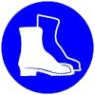 | Safety boots  Safety boots, also called steel capped boots, are needed if there is a risk of objects falling on your feet. Note that this includes sharp objects that may not necessarily be heavy.

Ear protection
If you're working in a noisy area, you should always wear ear muffs or ear plugs. Bear in mind that even if the noise isn't uncomfortably loud, it can still cause long-term hearing damage if you're subjected to it day after day over a long period of time.

Eye protection
Safety glasses or a face shield should always be worn if you're doing a job that generates flying particles that might get in your eyes. Goggles might be required where there are fine dust particles or mist from sprays.

Dust mask
If you generate dust that can't be collected in an extraction system, you should wear a dust mask to protect your lungs. In the case of fumes, spray mist and toxic gases, you may need to wear a specialised respirator.

Gloves
Gloves are useful if you're handling materials that could damage your hands. They should also be worn when you do jobs that involve hazardous substances that may be absorbed through the skin.

Learning activity
What items of PPE are you required to wear at work? Think about these items under the categories shown below. Also think about why they are necessary and what hazards they are protecting you from.
- General items while on-site. These may include safety boots and high visibility clothing.
- Specific items while in particular areas of the workplace. These may include ear muffs and safety glasses while in the factory or near any machinery.
- Specific items while doing certain jobs. These may include a hard hat when working with an overhead crane, or a face shield when welding.
Share your answers with your trainer and other learners in your group.

Manual handling
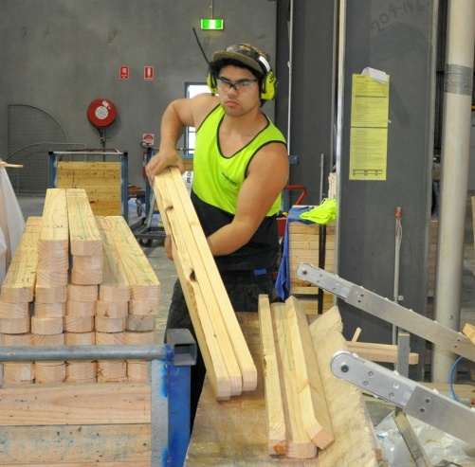
Whenever you're doing work that puts a strain on your muscles or joints, you need to think about the manual handling techniques you're using. This includes the methods you use to lift and carry objects, push and pull loads, and even the way you stand, sit or crouch while you’re working.
It's worth keeping in mind that manual handling injuries don't always result from an isolated event. That is, they're not always 'accidents' that suddenly happen without warning.
If you often use poor techniques while you're working, you can develop a chronic condition over a period of time, and in some cases, end up with permanent damage to the joints or tendons you’ve been over-stressing.

Looking after your back
One of the most common types of manual handling injury is back injury. This is sometimes caused by lifting a load that's too heavy, but it can also occur from pushing or pulling a load, or twisting while your back is under strain. Let's look briefly at the structure of the spine to see why your back is vulnerable to injury.
The spine is made up of a set of vertebrae stacked one on top of another. Between the vertebrae are discs, which act like shock absorbers – compressing when the spine is bearing a load, and springing back again when the load is taken away.
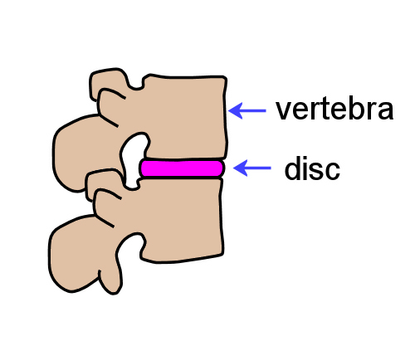
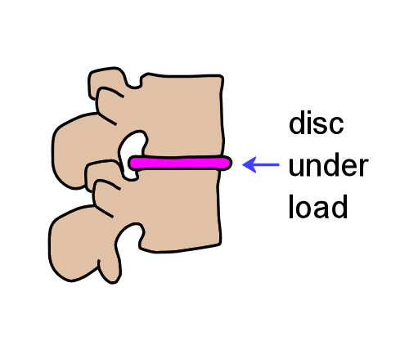

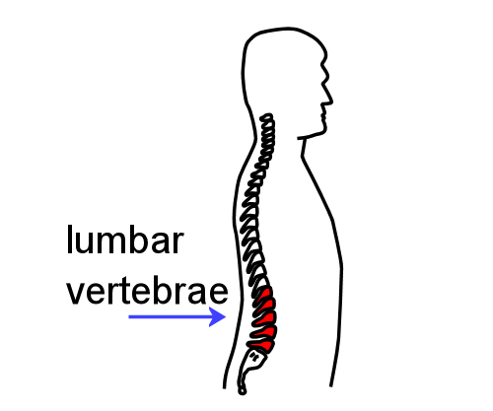
The real problem area for most people is the lumbar region. This is because the discs can only cope with maximum pressure when your pelvis is level and your spine is in a balanced position above it.
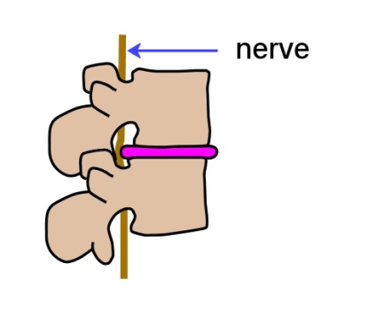
So when you bend forward or to one side, or twist while holding a load, you’re putting uneven stresses on the discs in addition to the extra weight they have to bear.
Many injuries result from fatigued muscles going into spasm, causing back pain and difficulty in standing up straight.
In serious cases, a bulging disc can rupture and come into contact with a nerve in the spinal cord. Some people call this a 'slipped disc'.
So how does this affect the way you should work?
The general rule is – try to avoid putting too much stress on your back when:
- bending forward
- bending sideways
- twisting
- reaching past a comfortable distance.

Learning activity
There are lots of mechanical aids designed to reduce the amount of manual handling workers need to do in the workplace. They range from expensive machines like forklifts and gantry cranes to simple devices like trolleys and rollers.
What mechanical aids do you use in your workplace? Write a list of the machines or devices you use, and beside each one state the materials or products you handle with it. Share your answers with your trainer or other learners in your group.

Assignment 2
Your task is to carry out a risk assessment in your workplace. You may choose:
- a particular machine that you work with or are planning to work with
- a work process that you regularly undertake.
For each of the hazards you identify:
- describe the tasks where they occur
- rate the risk of injury or illness from 1 to 6, using the Risk Assessment Table shown earlier in Assessing risks.
- suggest practical control measures that would minimise the risks, in keeping with the risk rating you have given the hazard. Use the ‘Hierarchy of controls’ shown on the Controlling risks page.
Risks to be assessed:
- Pinch points and crush injuries
- Cuts, punctures or strikes
- Hydraulic or pneumatic leaks
- Electrical hazards
- Manual handling injuries
- Operator controls and isolation problems
- Slips and falls
- Personal protective equipment
- Lighting
- Fatigue management
- Traffic control.

Section 3

Dealing
with emergencies

Overview
Emergencies are situations that are dangerous to life, property or the environment. They may arise from a fire, explosion, industrial accident, or some other incident that occurs without warning.
By their very nature, emergencies are unexpected and catch people by surprise. But if the site has already trained its staff and put procedures in place to cope with the incident, it will be better placed to bring it under control quickly and minimise any damage or injuries.
In this section we’ll discuss various types of emergencies that workplaces need to be prepared for. We’ll also describe the general procedure for carrying out an emergency evacuation.

Working through this section
The assignment for this section will test your knowledge of the emergency procedures and precautions in place at your workplace. Have a look at Assignment 3 on page 54 to see what you’ll need to do to complete it.
There are also three lessons for this section:
- Emergency evacuations
- On-site fires
- Hazardous spills.
These lessons will provide you with background information relevant to the unit of competency.

Emergency evacuations
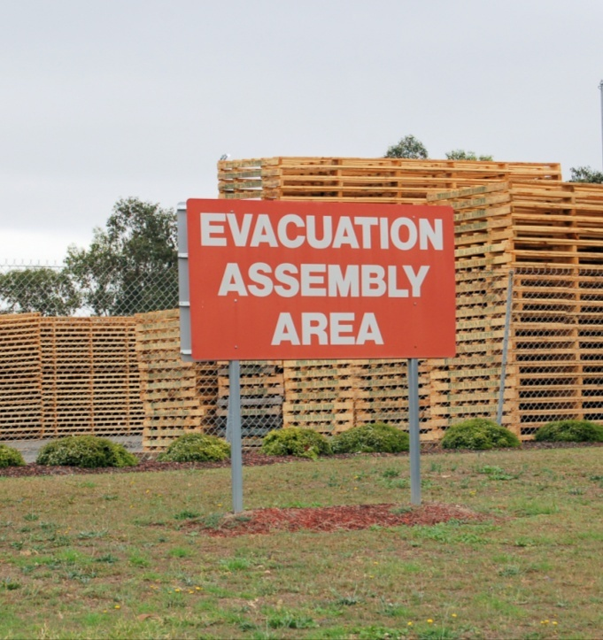
Most workplaces have an evacuation procedure in place, with a designated Assembly Area for people to go to. The evacuation procedure and site map are often posted up in various places around the worksite.
Company Policies and Procedures Manuals generally specify that an emergency evacuation drill will take place periodically, so that everyone working at the site knows what the alarm sounds like, and can practice the process of shutting down their equipment, leaving their work station, and going to the assembly area to have their name marked off.

General emergency evacuation procedure
Here is a typical procedure for dealing with an emergency evacuation situation.

Raising the alarm
If you are the first person alerted to the emergency:
- Notify your supervisor or manager immediately, or send another person to convey the message to management.
- If it is safe to do so, attempt to control the emergency by isolating the power supply, or using the appropriate equipment.
- If safe, remove any people in immediate danger of further injury from the area.
- Follow all directions regarding evacuation of the area from your supervisor or manager.

Evacuation procedure
If you are told to evacuate, or if you hear the emergency evacuation alarm:
- Stop what you are doing and switch off the power in your immediate work area, if possible.
- Take the safest route to the Emergency Assembly Point, or the front gate of the site.
- Advise other personnel along the way to evacuate.
- Ensure that you have been accounted for by your supervisor or company management.
- Wait at the assembly point until directed otherwise by management or the emergency services. Do not go in search of other personnel unless given explicit instructions from an authorised person.

Notifying emergency services
If it is your place to call the emergencies services for help, you should dial ‘000’, remain calm, and provide the following information:
- your name
- location
- location of the emergency
- number of people injured
- types of injuries sustained
- assistance required; such as ambulance or fire brigade
- any hazards that might exist; such as toxic fumes or spilt chemicals
- contact phone number.

Vehicles drivers
If you are driving a vehicle on-site when the emergency alarm sounds, you should:
- pull over to the side of the road or access way
- park the vehicle, making sure it is well clear of any thoroughfare that may be needed for emergency vehicles
- leave the vehicle unlocked, with the keys in the ignition
- report to the Assembly Area.

Learning activity
Provide short answers to the following questions.
- How are employees at your site made aware of the emergency evacuation procedures? Are the procedures posted up in particular areas around the workplace? Is a site map included showing the emergency assembly point?
- When was your last emergency evacuation drill? How did it go? Were there any problems identified that needed to be addressed? If so, how have they been addressed?
Share your answers with your trainer and other learners in your group.

On-site fires
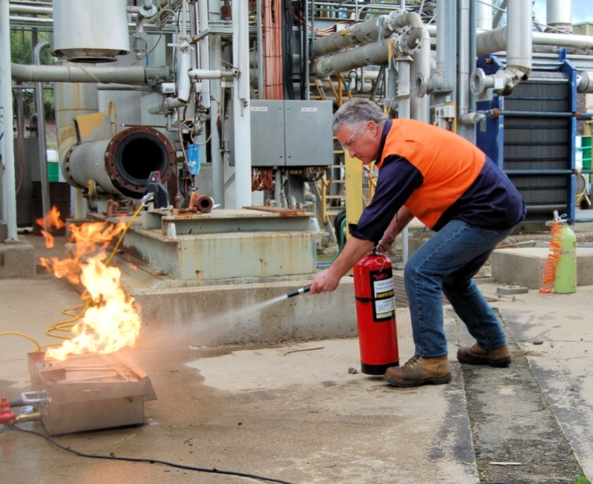
Combustible and flammable materials are present in every workplace. These fuels could include:
- cardboard and paper
- plastics
- timber and sawdust
- desks, chairs, shelving and other fittings or furniture
- petrol, diesel and gas
- solvents and other chemicals stored on-site.
There will also be various ‘ignition sources’ that may set these fuels alight under the right conditions, such as:
- electrical sparks from faulty machinery or loose wiring
- sparks from welding or grinding activities
- naked flames from matches or cigarette lighters
- smouldering cigarette butts.

Prevention
The two most important prevention measures you can take to avoid the possibility of a fire are:
- maintain good housekeeping
- keep potential ignition sources away from flammable and combustible materials.
This means that you should always try to keep the workplace clean, especially at the end of the day before you knock off, and always make sure that any activities that may cause sparks or flames are carried out well away from fuel storage areas. The most obvious example of this is to avoid smoking near gas, petrol or diesel storage tanks or refuelling areas.

Fire fighting equipment
Fire extinguishers and hose reels are the most common equipment kept to fight fires on-site. Fire extinguishers are colour coded and labelled according to their contents.
It's very important to match the correct extinguisher to the type or class of fire. The contents of some extinguishers may be unsuitable ― or even dangerous ― if used on the wrong type of fire. The tables below show the different classes of fire and the range of fire extinguishers used to combat these fires.

Classes of fire
Fire classes are categorised according to the type of material that is burning and range from Class A to Class F.
Class | Symbol | Fuels | Examples
A | 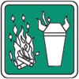 | Ordinary combustible solids | Wood, paper, cloth, plastics, rubber, coal
B | 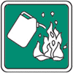 | Flammable and combustible liquids | Petrol, oil, paint, thinners, kerosene, alcohol
C | 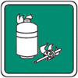 | Flammable gases | LPG, butane, acetylene, hydrogen, natural gas
D | 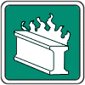 | Combustible metals | Magnesium, aluminium, sodium or potassium
E | 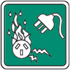 | Electrical fires | Computers, switchboards, power-boards
F | 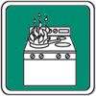 | Cooking oils and fats | Cooking oils and fats usually found in industrial kitchens

Fire extinguisher colour codes and labels
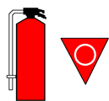 | Colour: Solid red.  Contents: Water.  Label: Class A fires; paper, wood, cardboard.  Dangerous if used on cooking oils, fats electrical fires.

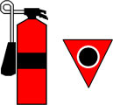 | Colour: Red with a black band.  Contents: Carbon dioxide.  Label: Class E fires; electrical.

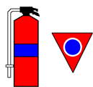 | Colour: Red with a blue band.  Contents: Foam.  Label: Class A and B fires; paper, wood, cardboard, and flammable and combustible liquids, e.g. methylated spirits.  Dangerous if used on electrical fires.

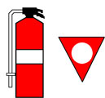 | Colour: Red with a white band.  Contents: Dry chemical or powder.  Label: Class A, B, C and E fires; most fires except for oils and fats.

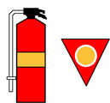 | Colour: Red with an oatmeal band.  Contents: Wet chemical.  Label: Class F fires; cooking oils and fats; also paper and wood.  Dangerous if used on electrical fires.

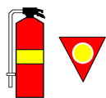 | Colour: Red with a yellow band.  Contents: Vaporising liquid.  Label: Class A and E fires; paper, wood, cardboard and electrical.

How to use fire fighting equipment

Fire extinguishers
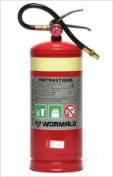
To use a fire extinguisher:
- pull out the pin
- squeeze the handle while aiming the hose at the fire
- use a sweeping action to spray the substance back and forth across the fire, from front to back and from side to side.

Hose reels
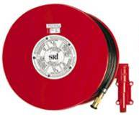
Hose reels use water, and are only designed for Class A fires, that is, fires involving materials such as paper, wood and cardboard. They must never be used on fires involving fats or electrical equipment. To use a hose reel:
- turn the water on at the reel before unrolling the hose
- unroll the hose, with the assistance of another person if required
- turn the water on at the nozzle.

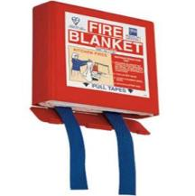
Fire blankets
Fire blankets are useful for smothering small fires associated with cooking stoves or other high-risk electrical appliances.
To use a fire blanket:
- pull the tabs downwards to remove the blanket
- shake the blanket open, holding onto the tags
- hold the blanket in front of the body to form a heat shield
- if an appliance is on fire – place the blanket over the fire and turn off the source of the flame
- if a person’s clothes are on fire – wrap the blanket around the person and roll them on the ground.

Learning activity
Have a look around your workplace to see where the fire fighting equipment is located. Answer the following questions:
- Where are the fire blankets situated?
- Are there any hose reels? If so, where are they positioned?
- Where are the fire extinguishers located? What are their contents and what types of fires are they designed for?
Share your answers with your trainer and other learners in your group.

Hazardous spills
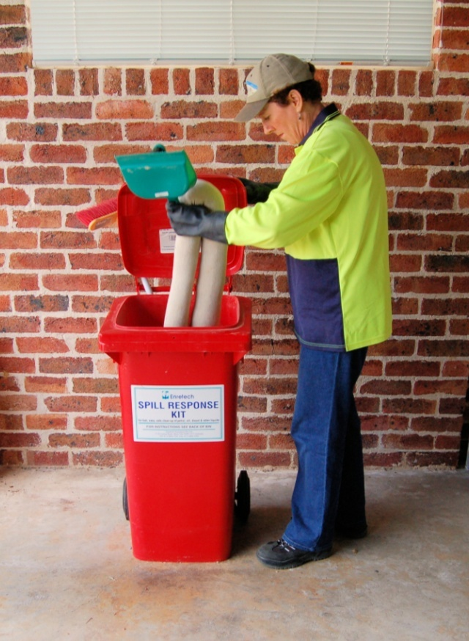
Some liquids are classified as hazardous because they have the potential to cause harm if they are stored or handled incorrectly. The sorts of hazardous liquids that you’re most likely to come across include:
- fuels, such as petrol, diesel and LP gas
- solvents, such as paint thinners, methylated spirits and turps
- poisons, such as pesticides and herbicides
- acids, such as battery acid or hydrochloric acid
- glues, sealants and coating products.
Spills can be a real problem when they involve a hazardous substance. They should always be cleaned up straight away, no matter how small they are.

Response for a small scale spill
The general response for a small scale spill is:
- Stop the source of the spill straight away, if it’s safe to do so.
- Contain the spill, using the materials in the spill kit.
- Clean up the spill, in accordance with the Material Safety Data Sheet (MSDS).
- Store the clean-up waste in a sealed container.
- Contact a licensed waste contractor to take away the waste materials.
If a spill occurs that might harm the environment, you must tell the EPA or local council as soon as you become aware of it.
For serious spills, or where there is any doubt about the safety of the situation, contact the Fire Brigade on 000.

Material Safety Data Sheets
Every manufacturer of hazardous substances is required to produce a material safety data sheet (MSDS) for each substance. This document provides information on how to use the product safely, what to do in the event of a spillage, and how to handle other health, safety and environmental care issues.
Many companies produce their own MSDS summaries, which they develop by taking the full MSDS and turning it into a one-page ready-reckoner for the workers who use the products. These summaries can then be laminated or pinned up on the wall near where the products are stored.
On the following page is an example of a workplace MSDS summary.

Learning activity
Choose one hazardous liquid you use at work and answer the following questions.
- What is the name of the product?
- Where is the MSDS kept?
- What is the procedure for dealing with a spill, as shown in the MSDS?
Write your answers down and share them with your trainer and other learners in your group.

Assignment 3

1. Emergency evacuations
Answer the following questions in relation to the emergency evacuation procedure at your own workplace:
- Where is the emergency assembly area?
- What is the signal for an emergency evacuation (for example, is it three bursts of the hooter)?
- Briefly describe the procedure that people must follow for an emergency evacuation

2. Fire extinguishers
For each of the fire extinguishers shown below, answer the following questions:
- What are the contents?
- What class or classes of fires the extinguisher designed for?
- Which types of fires is it not suitable for?

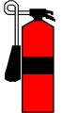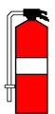

3. Material safety data sheets
Choose an MSDS for a hazardous substance that you use at work and answer the following questions:
- What is the name of the product?
- What is the product used for?
- What PPE is required when handling the product?
- Where should the product be stored?
- What is the procedure for dealing with a spill?

Practical demonstration
The checklist below sets out the sorts of things your trainer will be looking for when you undertake the practical demonstrations for this unit. Make sure you talk to your trainer or supervisor about any of the details that you don’t understand, or aren’t ready to demonstrate, before the assessment event is organised. This will give you time to get the hang of the tasks you will need to perform, so that you’ll feel more confident when the time comes to be assessed.
When you are able to tick all of the YES boxes below you will be ready to carry out the practical demonstration component of this unit.
General performance evidence | YES
- Identify hazards in the work area before and during work
- Assess risks and identify control measures to minimise risks
- Review effectiveness of controls and identify and report remaining risks
- Follow workplace procedures to implement controls and use appropriate PPE
- Handle and store hazardous materials safely
- Recognise emergency situations and follow emergency workplace procedures
- Follow workplace procedures for dealing with a range of emergencies
- Raise WHS issues with designated personnel according to workplace procedures
- Contribute to safety in the workplace within scope of responsibility by providing input in: WHS arrangements, control measures, opportunities for development and reporting of non-routine hazards
- Follow workplace safety procedures, WHS laws and regulations
- Identify the rights and responsibilities of employees and employers under WHS law
- Complete hazard, incident or accident reports (with assistance, if necessary)

