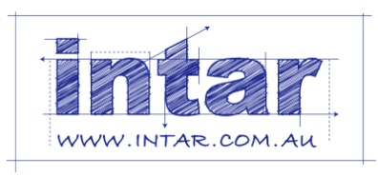
Supporting: MSFGN3001: Read and interpret work documents

Section 2 Assignment: Other documents
Name |  | Date
List 10 different types of documents that you use at work. There must be at least one example of each of the following documents:
- Australian Standard
- manufacturer’s installation guidelines or technical manual
- material safety data sheet
- work plan, project schedule or equivalent
- building code or project specification
- safe operating procedure or equivalent
- safe work method statement, job safety analysis or equivalent
For each of the documents you have chosen, answer the following questions:
- What is the full title of the document?
- What is its purpose?
- Who is responsible for looking after it and making sure the employees are using the latest version? (Give the job title of the person, not their name.)
- What is the version control system – that is, how do you know you’re looking at the latest version?
- Where is it kept at your workplace, and if there are multiple copies, who has copies? (Give the job titles of the people who have their own copies.)
- Who would you consult if you were out on-site and had a query about a detail in the document? (Give the job title or role of the person you would consult.)
Use the tables on the following pages to complete your answers.
Document 1
Title
Purpose
Person responsible
Version control
Where kept / who has copies
Who to consult

Document 2
Title
Purpose
Person responsible
Version control
Where kept / who has copies
Who to consult

Document 3
Title
Purpose
Person responsible
Version control
Where kept / who has copies
Who to consult

Document 4
Title
Purpose
Person responsible
Version control
Where kept / who has copies
Who to consult

Document 5
Title
Purpose
Person responsible
Version control
Where kept / who has copies
Who to consult

Document 6
Title
Purpose
Person responsible
Version control
Where kept / who has copies
Who to consult

Document 7
Title
Purpose
Person responsible
Version control
Where kept / who has copies
Who to consult

Document 8
Title
Purpose
Person responsible
Version control
Where kept / who has copies
Who to consult

Document 9
Title
Purpose
Person responsible
Version control
Where kept / who has copies
Who to consult

Document 10
Title
Purpose
Person responsible
Version control
Where kept / who has copies
Who to consult

